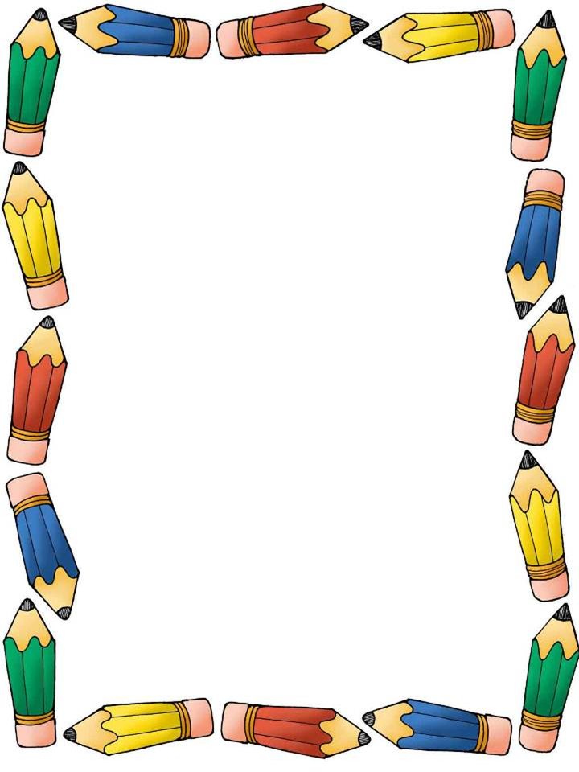

**Prairie-Hills Elementary School District 144**

***1st Grade Supply List***

**1- Pencil Pouch w/zipper or Plastic School Box**

**2- No. 2 Sharpened Pencils 24ct/boxes**

**2- Pink erasers**

**1- Pack of Pencil tip Erasers**

**2- Boxes of Crayola Crayons 24ct.**

**1- Colored Pencils**

**2- Yellow Highlighters**

**1- Pair of Blunt tip Scissors**

**1- Bottle of Glue**

**2- Pkgs. Glue Sticks**

**1- Small Index Cards (lined)**

**6- Wide rule Spiral Notebooks**

**6- 2-Pocket folders (solid colors only)**

**1- Box 1 Gallon Ziploc Bags**

**1- Box Sandwich size Ziploc Bags**

**4- Boxes of Kleenex**

**2- Pkgs. individual Kleenex (Pocket Size)**

**4- Rolls of Paper Towels**

**2- Clorox Disinfectant Wipes**

**1- Baby Wipes**

**1- Large bottle of Hand Sanitizers**

**1- Bottle of Liquid Soap**

**1- Book bag (no wheels)**

**1- Pair of gym shoes (To be left at school.)**

**Face Masks (Disposable or Reusable)**

**Headphones**

**\*Please put your child’s name on ALL supplies.**

**\*All Teachers will have supply baskets for students.**

**\*REPLACEMENT of supplies during the year is the student’s**

**responsibility.**

***Revised 07/01/2020***